Chapter 6 Methodology and Application of Data Augmented Design: A Case Study of Urban Redevelopment Design for the Panyu-Xinhua Area, Shanghai

Tianyu Su, MIT, United States of America, and Shihui Li, Jing Li, Hungyu Chou and Ying Long*, Tsinghua University, P.R. China

* Corresponding author, Ying Long, ylong@tsinghua.edu.cn

1 Introduction
The tension between science and design has been a long-debated issue in the field of urban planning and design. How should design, a traditionally bottom-up approach of feature-capturing based on fieldwork, site visits and surveys, be integrated with science, a deductive approach to understanding the city through universal laws from above? (Townsend, 2015). In response, the introduction of systems science for urban studies raises the issue of ‘science for design/planning’, which concentrates on how to make cities and urban forms function and perform better through modelling. As for the perspective of urban planning and design, its focus has become ‘science in design/planning’, or how urban planning is done through systemic and scientific processes with goals like sustainability, resilience and competitiveness (Batty, 2013; Yang and Yamagata, 2017).
In an age defined by digital technology, the growing abundance of, and easy access to, massive urban data sets allows new urban science to validate theoretical suppositions about cities at an ever-increasing rate and level of detail (Townsend, 2015). Yet from ‘science for design/planning’ to ‘science in design/planning ’, in the field of urban planning and design, will the concerns and interests of citizens be better understood and satisfied through the guidance of new urban science? (Mueller et al., 2018). Is there any methodology that can appropriately respond to the new data environment?
Over the last few decades, computer aided design (CAD), decision support systems (DSS), geographical information systems (GIS) and planning support systems (PSS) have been developed to respond to the new era, enabled by new technologies and data (Long et al., 2011). However, PSS are facing challenges and bottlenecks with the boom of big data and open data, such as the difficulties in comprehending the systems, their limited functions and applications, and the lack of motivation by planners (Liu et al., 2014). To meet the rapid development of artificial intelligence, machine learning, then internet of things (IoT) and many other digital and information technologies, more powerful theories and methods are needed to better interpret our cities (Batty, 2013).
At the same time, quantitative urban studies focusing on the measurement of urban form, quality, vitality and evaluation of urban design have been launched to re-examine cities at a much more refined level (Song, 2016). To name just a few, Bao et al. (2017) planned bike lanes on the basis of bike-sharing trajectories, and Andrienko et al. (2017) proposed that existing intelligent transportation systems can be further improved by the science of visual analytics in the future. However, the majority of existing research studies only concern an evaluation of the status quo or problem recognition within the urban system, and the proportion of research that is future-oriented is relatively small.
In response, Long and Shen (2015) propose a new planning and design methodology termed data augmented design (DAD) to highlight the application of data in the planning and decision-making process and improve the science of planning and design. Empowered by quantitative urban studies, the application of empirical data analysis in DAD not only improves the scientific level of urban planning and design but also sparks the inspiration and creativity of planners and designers. DAD is not software or a platform; it presents a methodology to comprehend the physical and social environment, which can be utilized to indicate the future environment and urban life in our cities.
Moreover, the aim of DAD is to fill the gap between the support systems used to understand the existing physical and social environment and the methods and tools applied for future-oriented programming, planning and design. As a new support system for the whole planning and design process, compared with preceding supporting platforms, the advantages of DAD lie in its simple and direct approach, full use of new data as well as traditional data, emphasis on urban planning/design and its evaluation, ease of use and respect to a site's uniqueness. Consequently, instead of rebelling against orthodox urban planning/design, DAD is dedicated to easing the burden of designers, emphasizing the inspirations that quantitative analysis would bring while enhancing the predictability and evaluability of urban designs (Long and Shen, 2015).
Therefore, the application of DAD ranges from field investigation, existing condition analysis and spatial parameter extraction to scheme design and future prediction, and has been gaining recognition in programs of both urban redevelopment design and ‘new district' construction (Long and Shen, 2015; Zheng, 2016; Zhou and Long, 2016; Cao and Long, 2017). Besides, positive feedback is returned continuously from the educational sector in institutions like Tsinghua University (Long, 2017).
Taking the urban redevelopment design theme associated with the Shanghai International Film Festival in the Panyu-Xinhua Area of Shanghai, as an example, this chapter illustrates the feasibility of applying DAD in historical built-up areas, where approaches like abstract spatial models, data mining and visualization, and the processing of natural languages, are applied. Is large-scale spatial intervention needed and in which way can it be achieved? How can communities be created that are suitable for different types of people? How can public space be designed which can promote the integration of different groups of people? As indicated at the beginning of this chapter, all the questions above are design questions and this chapter will be organized as follows: Section 2 reviews the diverse approaches of DAD in urban redevelopment programs. Section 3 discusses the application of DAD approaches applied in the Panyu-Xinhua Area of Shanghai in detail. Section 4 demonstrates the evaluation of these approaches and the chapter concludes with a further discussion in Section 5.

2 Methods and Tools of Data Augmented Design
DAD provides each phase of an urban design and planning process with support and enhancement, as a new quantitative planning and design methodology (Long and Shen, 2015). Developed on Esri’s ArcGIS platform, data were collected, cleaned, formatted and analyzed to improve the accuracy and creativity of the design process in the new data environment.
There are five steps in a typical DAD process (Long and Shen, 2015), shown in Figure 1: (i) data analysis of key urban design elements; (ii) site evaluation and stimulation of the urban design scheme; (iii) output of planning and design results; (iv) final results, reports and determinations; and (v) public engagement and city management. These steps overcome two main difficulties in traditional planning and design processes: firstly, they can integrate data and information from different sources and scales at the same scale for better analysis and application; secondly, the models are used to extract the most appropriate urban design elements and scheme, improving the science in this process by controlling the influence of personal preferences and judgements of planners and decision makers (Long and Shen, 2015). In this chapter, we focus on the first three steps (data analysis, site evaluation and stimulation, planning and design output) and try to figure out the appropriate methods and tools of DAD and verify their validity.

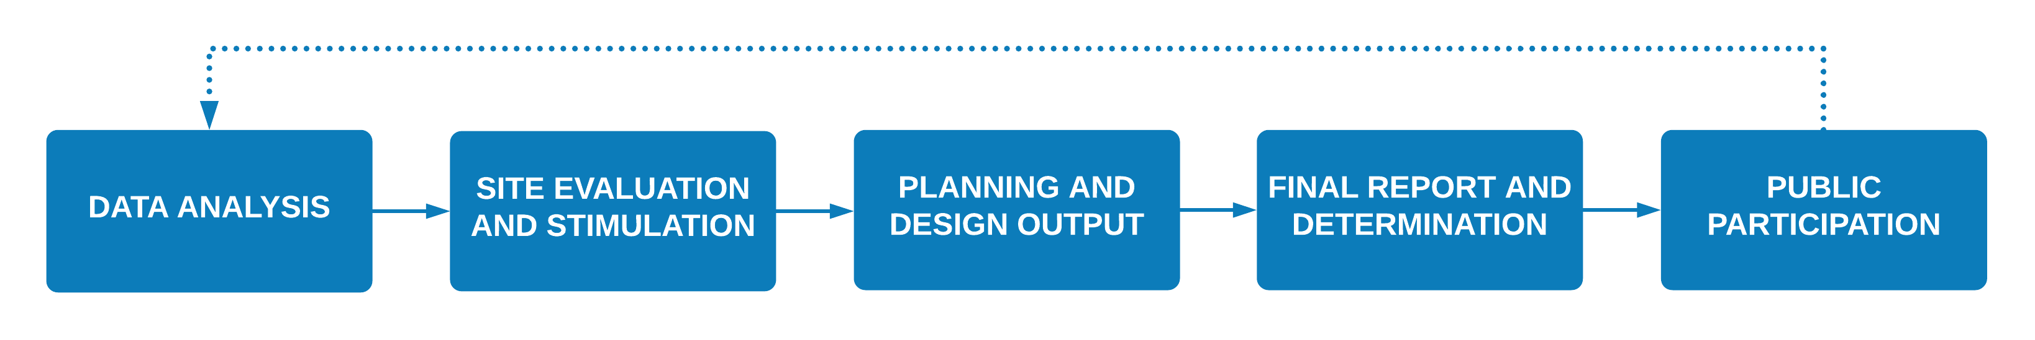
Source: Adapted by the authors from Long and Shen (2015)

Figure 1 Steps in a typical DAD application

2.1 DAD Users
The potential users of DAD are urban planners and designers, urban planning and management officers, and citizens. As the direct users of DAD, urban planners and designers might conduct urban studies including land use, transportation, space vitality and so on, as well as working on design proposals based on the results and then present the proposals to officers and citizens in a clear and accurate manner. The officers who are in charge of urban planning and management enjoy the convenience of monitoring and managing urban development and a smoother communication with planners, which makes them another user and beneficiary of DAD (Long and Cao, 2018; Long and Li, 2017). For the citizens caring about their future habitats, DAD provides a platform for them to witness and participate in the urban development process. Thanks to increasingly affordable devices, citizens themselves are also acting as real-time sensors of daily life (Ratti and Townsend, 2011), which could widen the data sources for DAD and improve its accuracy.
DAD will also intensify the communication and interaction among key players in city life, like officers, planners, developers, citizens and tourists. The open-source platform of DAD makes data analysis, data visualization and urban design much more transparent. Developers are able to co-work with planners to estimate the development potential, calculate the development intensity and choose the building styles, during which, officers and citizens can keep an eye on different phases of this process. Also, public participation and community engagement will become more viable and time-saving due to the new data platform.

2.2 Step 1: Existing Condition Analysis (Data Analysis of Key Urban Design Elements)
Identifying the key factors (KFs) of existing conditions and figuring out their control indicators is of great importance in urban redevelopment projects, which could/should be finished more quickly, more accurately and more conveniently with the help of DAD. Typical control indicators in urban redevelopment design include:
- Urban Fabric (F): this indicator refers to the usage of land, which may be a building or an open space like a road or a park; the value of F could be 1 for buildings and 0 for open spaces.
- Land Use Type (T): this indicator indicates the land-use condition of different buildings, communities or areas; the value of T could be residential (R), commercial (C), education (E), et cetera.
- Building Height (H): this indicator measures the height of existing buildings; the value of H ranges from 0 to 1,000 (metres).
- Building Quality (Q): this indicator indicates the quality of existing buildings in a research area; the value of Q is measured by a category value (1 for entirely poor and 7 for entirely good).
- Urban Activity Intensity (I): this indicator measures the spatial vitality of a particular area, which can be reflected by activities in social media; the value of I ranges from 0 to the maximum value of the variable.
Also, as a control indicator of existing condition analysis, transportation stations (S) which reflect on-site transportation conditions, are often collected and analyzed in the DAD process.
In DAD, these indicators are analyzed and visualized based on data from different sources, like social media, mobile phone signals, OpenStreetMap and so on. Each control indicator provides urban planners and designers with information concerning a specific section of the site. Different kinds of data will be introduced in Section 3.

2.3 Step: Spatial Parameter Extraction (Site Evaluation and Stimulation of the Urban Design Scheme)
A prominent task in urban case studies is how to quantify the urban information. As a quantitative planning and design methodology, DAD makes it possible for planners to analyze crucial urban information at a more accurate and systematic level. Urban data archives can be generated and used as a gene pool for urban redevelopment design. Similarly, with existing condition analysis, KFs and the control indicators are extracted. Taking the control indicators of urban fabric (F), land use type (T), urban activity intensity (I), and transportation stations (S) as an example — notably, DAD terms control alternatives (f, t, i, s) as the optional value(s) of control indicators, which can be found in Table 1 — the relationship between control alternatives and indicators is shown as follows:

V_{F} = {f₁, f₂ … f_{m}} (1)
V_{T} = {t₁, t₂ … t_{n}} (2)
V_{I} = {i₁, i₂ … i_{p}} (3)
V_{s} = {s₁, s₂ … s_{q}} (4)

where V_{F}, V_{t}, V_{i}, V_{F} are the control alternative set, and m, n, p, and q are the specific number of control alternatives for each control indicator, whose values vary according to site conditions.
Each spatial unit (U), which is a building, a community or an area, can be regarded as a four-dimensional coordinate defined by control indicators as U_{k} (f_{k}, t_{k}, I_{k}, s_{k}). A city in the urban data archive is a dataset of research units according to their geo-information. The data set could be generated and visualized in ArcGIS to make a series of diagrams.

Table 1 Examples of control indicators and control alternatives
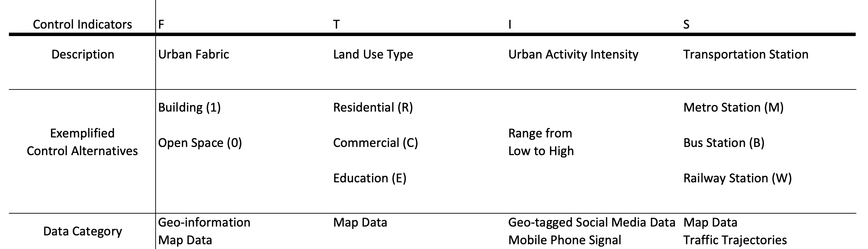

Besides, a street quality evaluation system is also applied in DAD, based on the theory and methodology of street view image assessment (Tang et al., 2016; Li et al., 2016). With the help of Google, an assessment system was established to evaluate the street view image in aspects like space accessibility, public space, green space, et cetera. A set of control Indicators (SQ_{ab}) is defined, where ‘a’ is the label of each evaluation factor and ‘b’ is the label of each city. The value of SQ_{ab} is supposed to be 1 (for satisfied) and 0 (for unsatisfied); i.e. SQ_{ab} = {0,1}.
In the evaluation process, training evaluators (urban planners and planning students) look through a series of street view images and submit their evaluation (0 or 1) for each image according to the criteria. As the development of image identification and generative adversary networks (GAN) progresses, computers are likely to take over this process soon.

2.4 Step 3: From Analysis to Urban Design (Output of Planning and Design Results)
As mentioned before, DAD is not only a study toolkit for urban spaces and the built environment, it is also a methodology guiding urban design. With the help of the existing condition analysis and spatial parameter extraction, planners can conduct the urban design process in four steps by:

- attaining an overall perspective towards the design area based on studies on a master plan and relative regulations;
- identifying the key problems of the design area, then figuring out the main tasks in following urban design according to the existing condition analysis and spatial parameter extraction;
- determining design guidelines and zoning regulations for the area after defining the dominant developing direction; and
- tailoring a dynamic urban design proposal for the area with the possibility for future upgrades.
The urban design process of the case study will follow these steps, which shows a typical usage scenario of the DAD methodology.

3 Application of DAD Approaches: Urban Redevelopment Design for the Panyu-Xinhua Area, Shanghai

3.1 The Panyu-Xinhua Area
The Panyu-Xinhua Area is located in Changning, Shanghai, where there are plenty of well-preserved historical buildings and attractive public spaces. This area has a strong sense of Shanghai culture and urgent issues faced in the urban redevelopment process, making it representative for testing out the existing condition analysis and spatial parameter extraction approaches of DAD.

Basic Situation and Problems
After a preparatory study of the Panyu-Xinhua Area, a basic image was developed of its strengths and weaknesses. Well-preserved historical and cultural buildings like the Shanghai Film Center (the host venue for Shanghai International Film Festival, SIFF) and the L. E. Hudec Museum (former residence of the famous Hungarian Architect) are easy to find in this site, but their surroundings are messed up by chaotic parking and unsustainable development. Several public spaces and green areas were constructed and used in past decades; however, a great number of them have bad conservation and are isolated from each other. Besides, as the host venue of SIFF, the Shanghai Film Center and its surrounding environment fail to meet the standards of modern spatial quality required by film festivals throughout the twentieth century.

Master Plan of City of Shanghai and Related Regulations
As a historical area located in the heart of Municipal Shanghai, the Panyu-Xinhua Area is under the control of the Shanghai Master Plan released by the Shanghai Municipal Bureau of Planning and Land Resources Administration (2016a; 2016b) several other related regulations released by governmental agencies like the Shanghai Municipal Transportation Commission (2016). Calling for a more human-oriented and culture-motivated Panyu-Xinhua Area, three key elements were extracted to guide the following research and design process: (i) give a positive response to the rapid development of information and communication technologies (ICTs) and data technology; (ii) improve the spatial quality of historical buildings and primary public spaces; and (iii) set up a smart service system adding more convenience to the daily life of residents.
To respond the requirements of the Master Plan and relevant regulations and to deal with the pressing issues facing the Panyu-Xinhua Area, the DAD methodology needs to work with traditional toolkits used by planners to analyze in an accurate and technology-based way and design in a human-centered sense.

3.2 Methodology in Practice
Working on the research and redevelopment project in Shanghai gave an excellent chance to test out the DAD methodology in the real world. Thanks to the rapid development of ICTs in China and the positive data environment, this project was able to be conducted smoothly.

Data Sources
Multiple sources of data are used in the DAD application, including big data, open data and traditional data as well (Long and Shen, 2015). In this case, data were collected, analysed and visualized in this research project; for instance, taxi trajectories from Didi, bike trajectories from Mobike, geo-tagged data from Flick and Weibo, and land-use records from OpenStreetMap, were all used. In addition to data from these internet service providers, information was collected in traditional ways from the Community Office. The type, source and what kind of analysis they were used for are listed in Table 2.

Table 2 Data sources
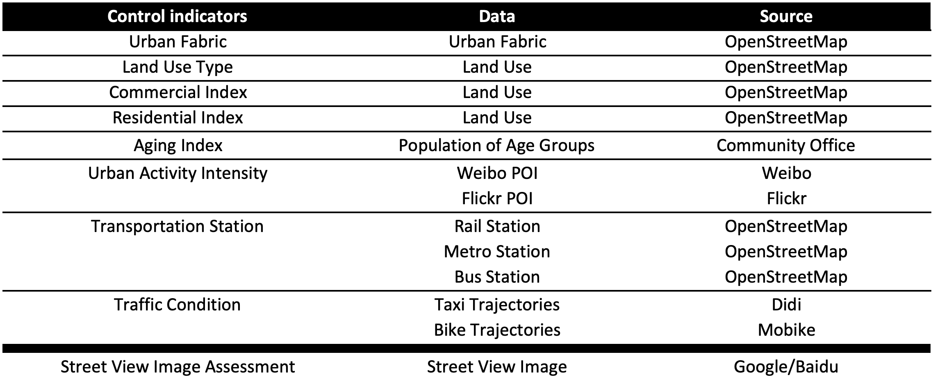

Existing Condition Analysis of the Panyu-Xinhua Area

Spatial usage and vitality (urban fabric, land use and activity intensity)
Since most of the buildings in our design area are well preserved and of good quality and building height is not a key factor in this case, we chose urban fabric (F), land-use type (T) and activity intensity (I) as the three key factors. Studies of these factors and their control indicators helped us gain a comprehensive understanding of the Panyu-Xinhua Area. Data from OpenStreetMap (an online platform for spatial data sharing) were imported into ArcGIS to visualize the basic situation of the urban fabric, land use, living and commercial parameters (based on the land-use information). Accordingly, the Panyu-Xinhua Area has a typical urban fabric in Shanghai as a historic community which is under the redevelopment, motivated by capital and governmental decisions.
The land-use diagram (Figure 2) shows that this site is highly mixed-use, including education, culture, residential, commercial and green space. A later study of the living and commercial parameters shows the land-use tendency of each block and suggests the potential for redevelopment at the same time. The prevalence of residential land use in almost every block required a human-centric design focused not only on upgrading of significant spaces but also the daily life of residents, while the unbalanced business development along Panyu Road, the main street, looked forward to a systematically data-based plan (Figure 3).

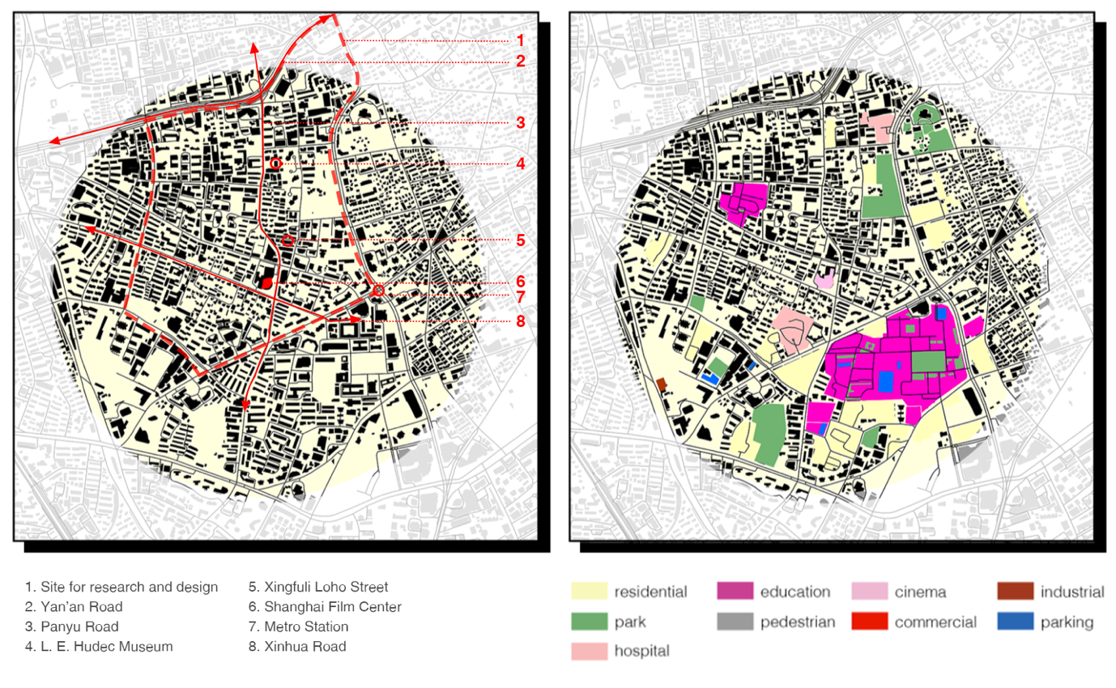

Figure 2 Diagrams of urban fabric (left) and land use (right)

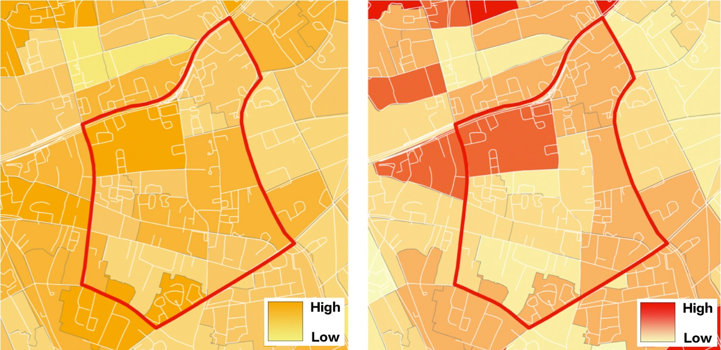

Figure 3 Diagrams of residential (left) and commercial (right) land use

Data from social media can be used to indicate the pattern of human activities in a defined space. In this case, we utilized the data from Weibo and Flickr to study the pattern of activities of domestic residents and tourists as well as foreign visitors. As can be seen in the Weibo and Flickr diagram (Figure 4) which indicates the urban activity intensity in our site, the vitality of space varies acutely between different blocks. Compared to the rest, the following parts are much more active: the west and north edge, which is the Yan'an Road Viaduct (Weibo); the southeast corner surrounding metro station (Flickr); the inner core – L. E. Hudec Museum (Weibo and Flickr); and the internal core space – Shanghai Film Center (Weibo and Flickr). As discussed, several public spaces have been planned, designed and constructed in the Panyu-Xinhua Area. However, they are fully utilized by residents and visitors according to the data from Weibo and Flickr. It was an urgent task to think about how to take advantage of these potential spaces in a smarter manner.

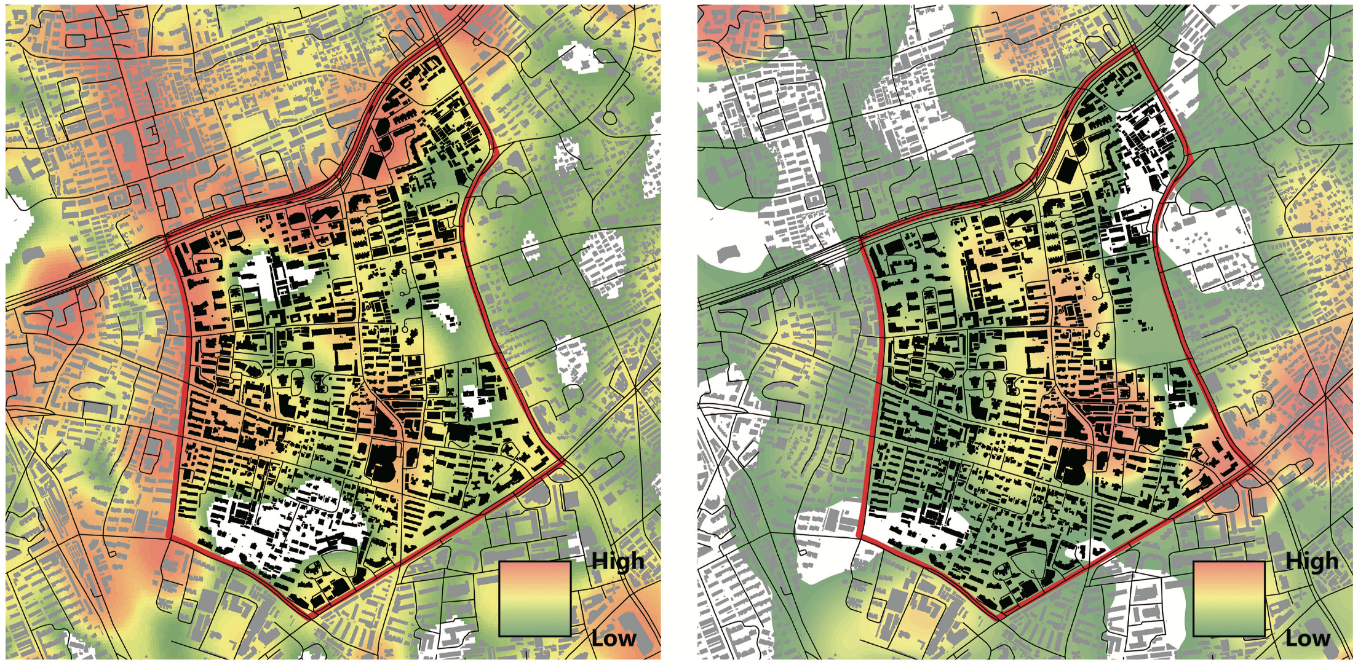

Figure 4 Diagrams of geo-tagged data analysis of Weibo (left) and Flickr (right)

Traffic trajectories (vehicles and bikes)
In the traditional transportation research process, traffic is always recorded by counting the number of vehicles or bikes at one point at one time, which is insufficient for designs. However, vehicle-mounted global positioning systems (GPS), car sharing platforms like Uber and Lift, taxi platforms like Didi and bike sharing platforms like Mobike, OFO and Bluebike, contribute together to form a positive data volume which could be read and analyzed on DAD platforms, where planners capture the flow of vehicles and bikes to compare different means of transportation and comprehend the mechanism behind this phenomenon.
It is well known that Didi and Mobike are popular in Chinese cities, especially in Shanghai, and both are used as characterizations of taxi and bike usage respectively. With the help of these two leading companies, taxi trajectories and Mobike trajectories were collected and analyzed in GIS to figure out the traffic intensity in different blocks. As can be found in the taxi trajectories diagram (Figure 5), on either weekdays or weekends, the taxi usage intensity differs across Panyu Road, the main street in the site. This situation is similar to the Mobike usage intensity, as shown by the Mobike trajectories diagram (Figure 6). The Mobike, however, show significant differences between weekdays and weekends, which could imply different user types, such as residents on weekdays and visitors on weekends. Comparing these two diagrams, there also exist several places enjoying high usage intensity both on weekdays at weekends, like the metro station, the Shanghai Film Center, Xinfuli Loho Street and the L. E. Hudec Museum, which could also influence the results of geo-tagged social media data analysis.

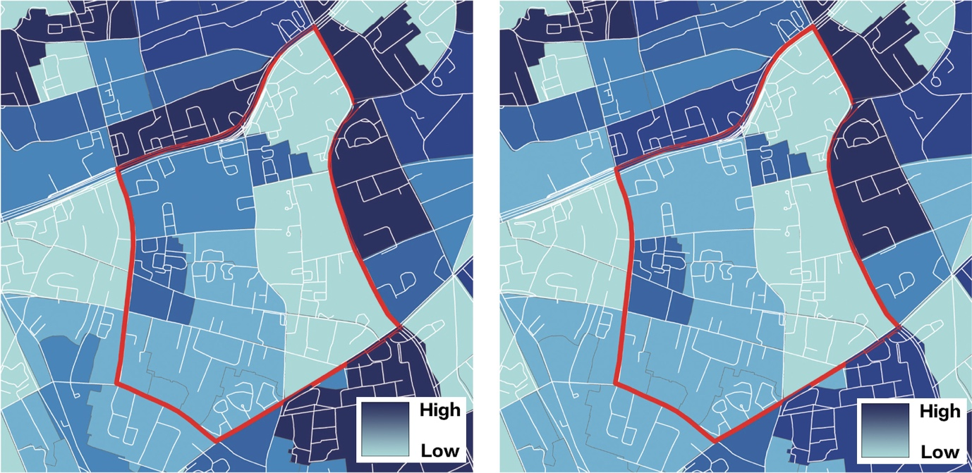

Figure 5 Taxi trajectories on weekdays (left) and weekends (right)

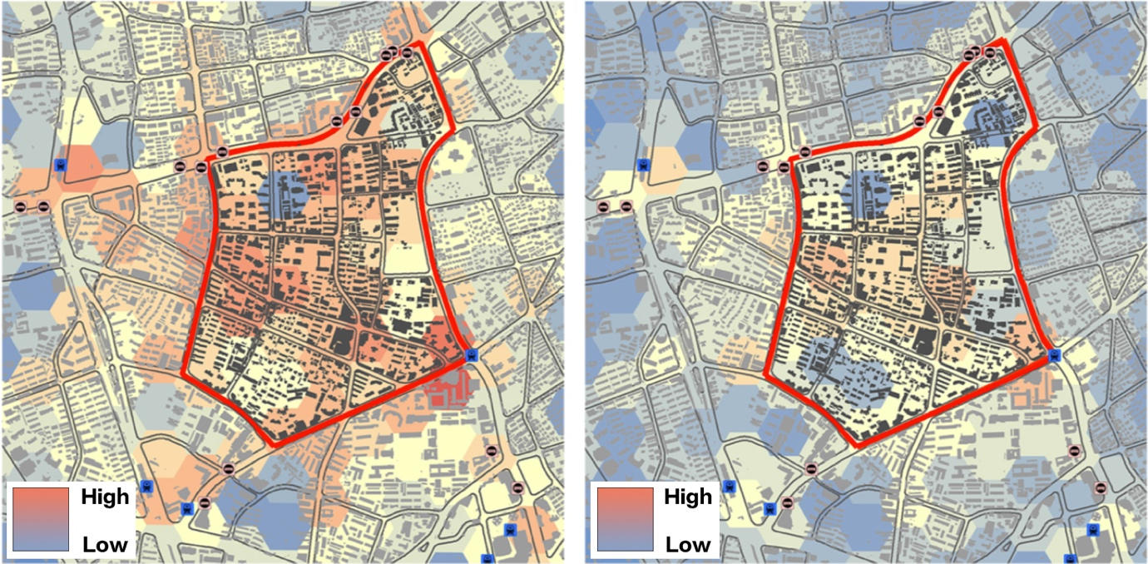

Figure 6 Mobike trajectories on weekdays (left) and weekends (right)

Word cloud
Apart from verifying spatial vitality, data from social media and search engines can also be used to understand public concern about a certain area. By calculating the search frequency of Google or Baidu or using the key world semantic analysis of Twitter or Weibo, researchers could easily focus on the main character or the theme of the site. During the process of site analysis, the creation of a word cloud can help researchers and planners better understand the site in a fast and humanistic way, since the data are bottom-up and collected from each space participant (Figure 7).
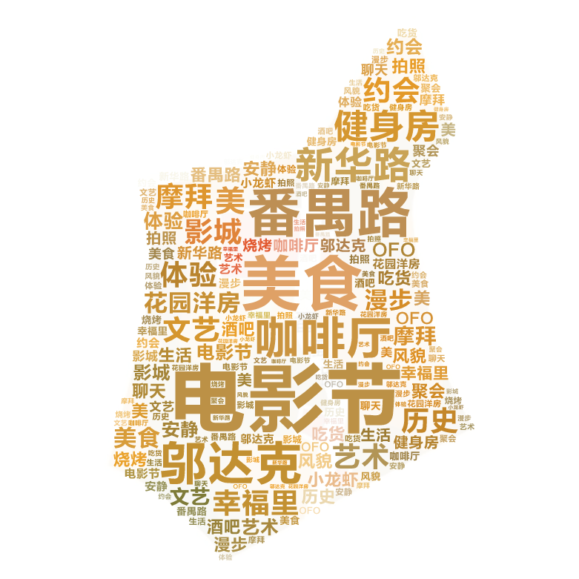

Figure 7 Word cloud

Based on the search frequency data mined from Baidu, the top search engine in China, a series keywords are extracted from amounts of searching results, which could mean what people are concerned most about the Panyu-Xinhua Area, the top five keywords are listed in Table 3.

Table 3 Top five key words in the word cloud
电影节 | 番禺路 | 美食 | 邬达克 | 新华路
Film Festival | Panyu Road | Delicious Food | L. E. Hudec | Xinhua Road

As shown in Table 3, cultural events like the Film Festival and historic spots like the L. E. Hudec Museum were searched at a high frequency, suggesting that the planners and designers should take upgrades of these places into consideration. At the same time, keywords like delicious food and several others unlisted also suggested the site is a combination of culture, history and daily life.

Spatial Parameter Extraction and Comparison Study
Urban data archive (urban gene pool)
After an overall study of the existing situation of the Panyu-Xinhua Area, comparative research was conducted with the data from OpenStreetMap and street view images from Google following the methodology introduced in Section 2. An urban gene pool was built up by analyzing and visualizing the data, including four aspects (urban fabric, land-use type, transportation stations and urban activity intensity) of essential information about the host venues for top-level film festivals all around the world, like Cannes, Berlin and Moscow. Next, a circular research range was set in each city, which was centered at the host venue with a diameter of 1 kilometre. As indicated in Figure 8, these communities where venues are located, enjoy significant differences in their natural and social environment, block size, transportation accessibility, et cetera. Despite the differences, this study revealed a common problem that almost all these neighbouring areas of film festival venues are facing, which is the limitation of the spatial influence by the events. We can observe from the diagrams (Figure 8, for each site, urban fabric, land-use type, transportation stations and urban activity intensity are presented from top to bottom) that the activities are concentrated within limited areas around the venues. However, given their location advantage, these neighbouring areas enjoy the privilege of future development motivated by the film festivals and related industry. This is one of the key points that has to be taken into consideration in the following planning and design process.
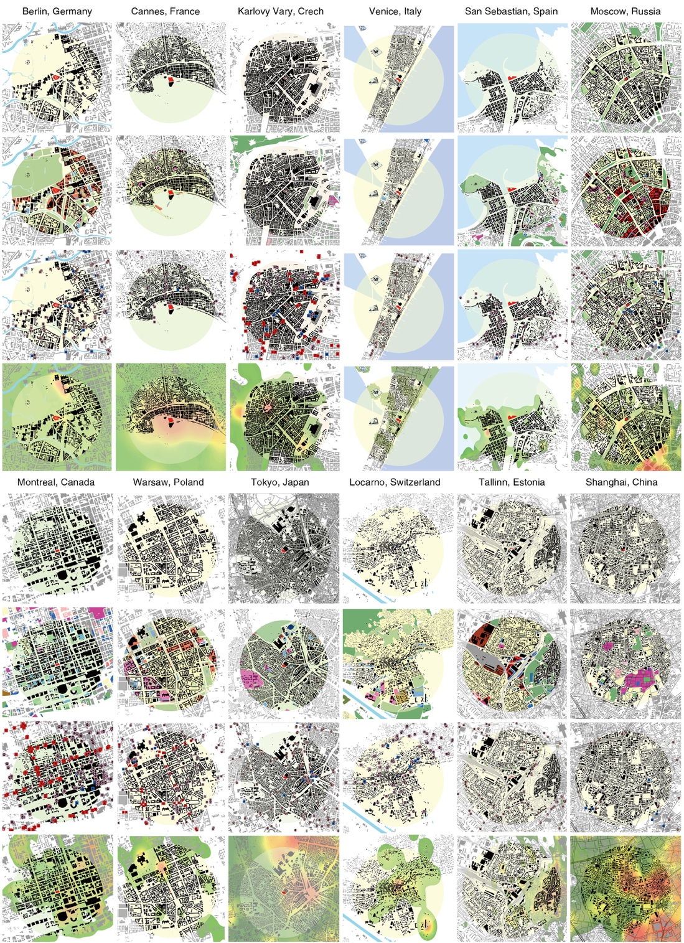

Figure 8 Urban data archive of the host venue for top-level film festivals

Street quality evaluation
A series of street view image assessments was undertaken by planners and well-trained professional students (Figure 9). The whole assessment system consists of a list of evaluation parameters, which have been widely recognized in the measurement of space quality, such as the walking environment, the building environment, and open spaces (detailed in Figure 9) (Tang et al., 2016; Li et al., 2016). Each parameter is measured in a scale from 0 to 1, then the average value is calculated and presented in Figure 9, with the highest value in each parameter colored in orange. As suggested by the results, the Panyu-Xinhua Area in Shanghai takes the lead in the building environment, community environment and street sanitation, while it is not walkable enough and needs more effort to improve the quality of public spaces and the street landscape compared to widely acclaimed host venues, like Cannes for example.

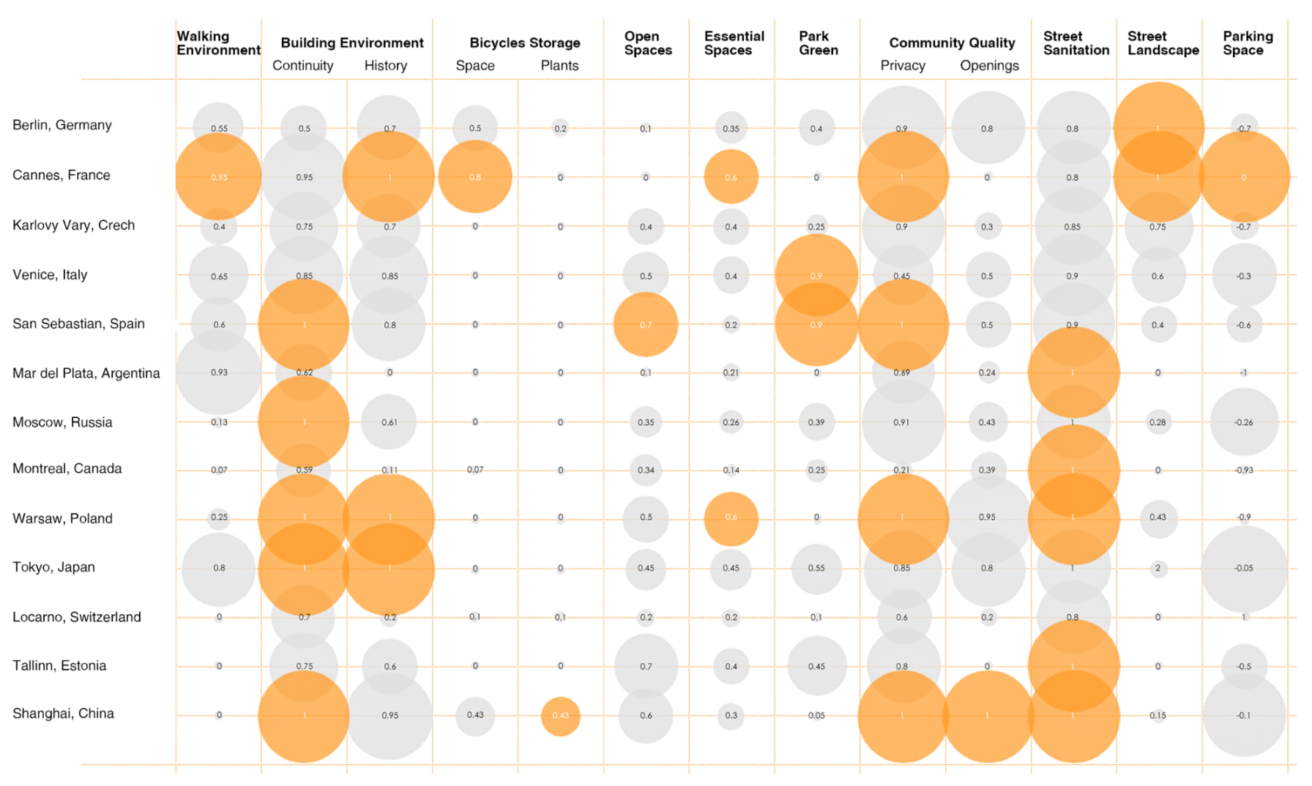

Figure 9 Google Street View image assessment of host venue for top-level film festivals

3.3 Main Tasks of Redevelopment Design of Panyu-Xinhua Area
After understanding the basic situation and preliminary problems, the Master Plan and relevant regulations, and the existing conditions and the urban archive, three critical issues had been extracted and summarized to guide the following planning and urban design procedures:

- to improve the unsatisfactory space quality of and around the Shanghai Film Center and its vitality limitations;
- to systematize the disorganized and underused public and green spaces in the Panyu-Xinhua Area so that residents (especially for the elders) and tourists can make better use of them; and
- to connect the daily life of residents and experience of visitors to the new development of ICTs and data technologies.

3.4 Urban Redevelopment Design for the Panyu-Xinhua Area
As discussed, systematic and human-centric design strategies were adopted to deal with the knotty and complicated issues facing this site. After thorough research and analysis, a series of design strategies were applied as follows (Figure 10):

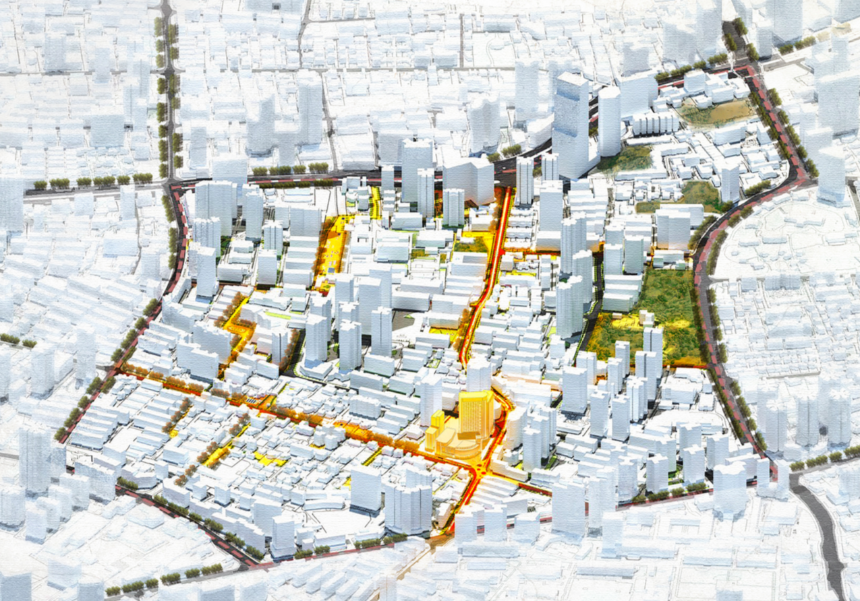

Figure 10 Aerial image of the urban redevelopment design

- Linear spaces themed with the Shanghai International Film Festival were connected by the Panyu Interactive Film Street (Figure 11) with human-scale streets and interactive amenities. To spread the vitality of film events, film-related spaces were designed alongside the Panyu Road, such as the SIFF Exhibition Platform and the Film Communication Center. The Shanghai Film Center, Xingfuli Loho Street, L. E. Hudec Museum, Film Communication Center, Shouxin Plaza Complex were connected to the newly programmed SIFF Exhibition Platform and Interactive Energy Center by a five-metre wide walkable and bicycle-friendly path. Besides, the surrounding environment of the Shanghai Film Center and L. E. Hudec Museum were also improved to satisfy the requirements of the redevelopment.
- The Xinhua Public Space System (Figure 12), a loop of open spaces, greens, parks and squares, was organized based on the results of the activity intensity study and site analysis. While the Panyu Interactive Film Street is an ambitious program for culture and history activation, this loop could be considered as an infrastructure system supporting the daily life and tourism of this whole area. Furthermore, necessary amenities, green and service spaces would improve the living and visiting experience while activating the underused spaces.
- A series of interactive hubs were placed on the Panyu Interactive Film Street and Xinhua Public Space System, which could promote new means of interaction between people and space. Information boards, mobile kiosks, interactive vapour generators and other facilities not only provide the places with more interest but also communicate with users to satisfy their demands and improve their experiences. At the same time, sensors inserted in these hubs are also collecting data from the environment and users to support dynamic design in the future.

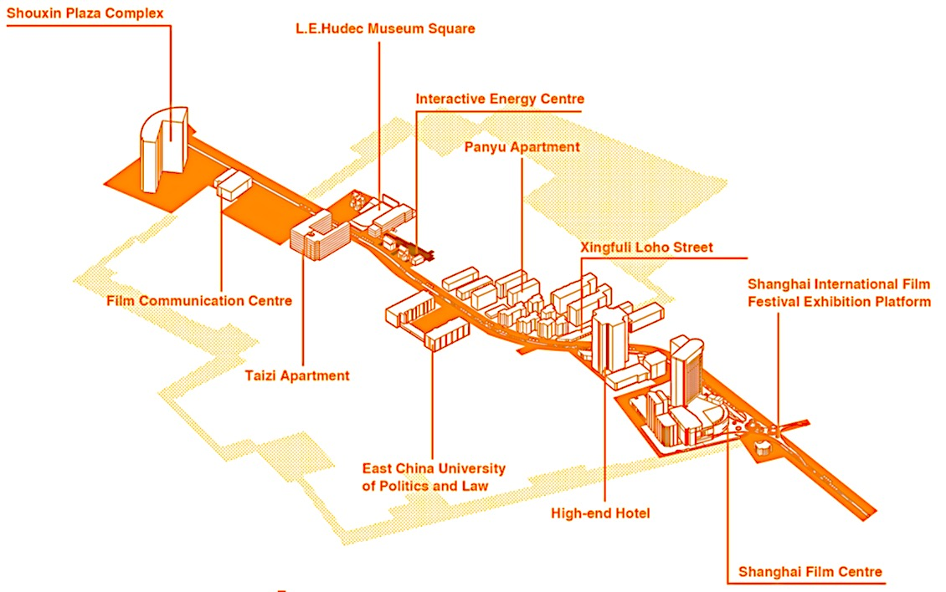
Figure 11 Panyu Interactive Film Street

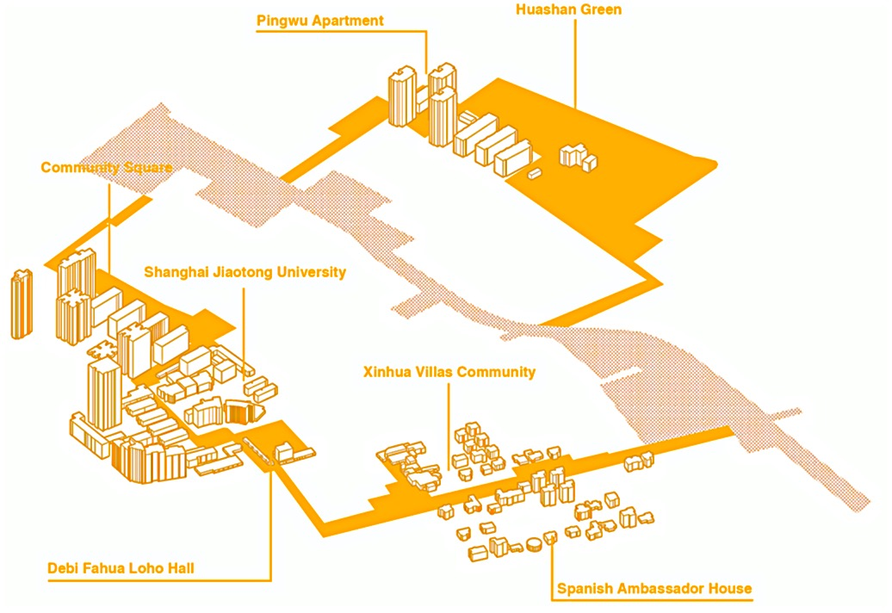
Figure 12 Xinhua Public Space System

4 Evaluation
By reviewing the DAD method and applying it to the field project, its advantages and future-oriented values are clearly illustrated. As a thematic design and an entry in the Shanghai Urban Design Challenge competition, the urban redevelopment design for the Panyu-Xinhua Area used the DAD method to seek breakthroughs in analysis and design methods, and won a Featured Achievement Award in November 2017. An evaluation by different users, like urban planners, officers and citizens, was collected after the competition.
From the perspective of urban planners/designers, compared with traditional planning methods, the DAD method applied in this project largely expanded the research dimensions of planners and helped them to discover new problems and their optimal solutions. Conventional approaches to urban design are relatively limited and only focus on a specific period and certain aspects of the issues, leading to an urban design which is difficult to evolve dynamically over time with the changing environment. However, the DAD method can find more comprehensive problems during multiple time periods, making the dynamic process of planning possible. For example, it can detect the conditions of traffic flows on the road at different times (such as working days and weekends, morning and evening, and peak hours and off-peak hours) through real-time detection and comprehensive analysis, and more specifically, it can support the improvement of the non-motorized traffic system.
Moreover, in the design of the Panyu-Xinhua Area, much attention was paid to the possible changing situation of the site in Shanghai at different stages of development according to the program analysis phase based on the DAD method. Planned and designed after estimating the dynamic environment, a large number of sensors for different purposes will be installed and deployed in the site simultaneously, which will collect different kinds of site data and transfer this information to planners to ensure the possibility of rapid adjustment of the design in the future.
Also, compared with traditional planning methods, which are usually limited to qualitative data collection and analysis, the DAD method is more objective and supportive of quantitative comparison and analysis. It can also discover the space hotspots in the site through geo-tagged social media data analysis combined with the prediction of new potential hotspots to organize holistic public space systems. It can build a case gene pool through spatial parameter extraction of similar spaces in different cities, which is more intuitive and convincing for case comparison and reference. Both have contributed a lot to the accomplishment of the urban redevelopment design for the Panyu-Xinhua Area.
From the perspective of city officers, the competition they organized offers the urban planning authority an opportunity to promote the organic process of urban redevelopment in historic districts, as well as the improvement of the urban environment which, in the long run, will make Shanghai an extraordinary global city. It is also worth mentioning that the combination of DAD system and carefully selected urban design program of great influence and public attention is going to form a prominent brand of creative urban planning in Shanghai, which is a win-win interaction, officially recognized by the Featured Achievement Award in Shanghai Urban Design Challenge, between academia and the Government.
As for citizens who are directly or indirectly involved in the redevelopment project in the Panyu-Xinhua Area, the application of the DAD method takes full consideration of people-oriented urbanism and public participation through the design of the human-scale urban fabric, the interaction between data collection and their everyday life (through the interactive information board, for example), and so on. Among these, the most to benefit are the elderly people who constitute a high proportion of the total population in this area. As the diverse spatial demands of citizens are gradually satisfied through the implementation of the DAD system, we will finally witness a new urban lifestyle in the digital age.

5 Conclusions
By reviewing the history and development of the relationship between data and design, as well as summarizing the progress of new data environment, this chapter introduces a new quantitative planning and design methodology termed data augmented design, which is proposed by Long and Shen in 2015. DAD provides a new supporting platform for the planning and design process, ranging from field investigation, existing condition analysis to future forecasting and scheme design.
Focusing on the analysis and design phases of DAD, the chapter focuses on two key toolkits of DAD research: existing condition analysis and spatial parameter extraction, followed by the introduction of methods and tools for each approach. To better present the DAD and evaluate the effectiveness and efficiency of DAD methods, the chapter has introduced a case study of the urban redevelopment design the Panyu-Xinhua Area to illustrate the DAD methodology. By evaluating the data collection, data analysis and urban design phases of DAD, we reach a conclusion that, urban planners, officers and citizens could all benefit from the application of DAD.
Potential applications of DAD lie in three areas: planning and design support; future estimation; and public participation. As a planning/design support system, DAD can be applied in urban planning and urban design projects of different scales and improve the accuracy and systematism of the planning and design process. Based on the urban data archive provided by DAD, researchers can figure out the different development phases of similar cities, summarize the common issues facing cities and forecast the future development of cities. As a platform generated and empowered by data, DAD can serve as a tool for monitoring, communicating and engaging communities, which could be used by planners, developers, officers and citizens.
While highlighting the merits of DAD, there are still issues that need to be improved in the near future. First, as the spatial distribution and condition of key urban factors are dynamic, the DAD framework needs to be updated accordingly. More efficient and convenient methods for analyzing need to be put forward. Second, although the volume of data is booming right now, more open data of high quality are still required. To improve the accuracy and resilience of the system, a more significant amount of data needs to be provided. Based on this, emerging technologies like machine learning could be applied to orientate future urban development. While there has been rapid progress of the IoT and individual sensors, the DAD system has the potential to contain more information to support urban planning, urban design and decision making in our cities, and develop into a more accessible and portable data system in the future.

Acknowledgements
This work was financially supported by the National Water Pollution Control and Treatment Science and Technology Major Project of China (Grant No. 2017ZX07103–002) and Tsinghua University (School of Architecture) CIFI Group Joint Research Center for Sustainable Community (Grant No. R201). We would like to thank the Shanghai Urban Design Challenge and Mobike for their data and other support. Our thanks also go to Yu Pei, Yang Zhang, Wenxin Yan, and Di Lu for their participation and contribution in the research and design process.

References
Andrienko, G., Andrienko, N., Chen, W., Maciejewski, R. and Zhao, Y. (2017) Visual analytics of mobility and transportation: State of the art and further research directions. IEEE Transactions on Intelligent Transportation Systems, 99: 1-18.
Batty, M. (2013) The New Science of Cities. Cambridge: MIT Press.
Bao, J., He, T., Ruan, S., Li, Y. and Zheng, Y. (2017) Planning bike lanes based on sharing-bikes' trajectories. ACM SIGKDD International Conference on Knowledge Discovery and Data Mining, 2017, pp. 1377-1386.
Cao, Z. and Long, Y. (2017) Methodology and practice of data adaptive urban design: Case study of slow traffic system design in Shanghai Hengfu Historical District. Urban Planning Forum, 236: 47-55.
Li, S., Yang, Z., Liang, X., Zheng, L. and Long, Y. (2016) Measuring quality of street space and its temporal variation: An empirical study in Dongsi Historical District. Beijing Planning Review, 171: 39-48.
Liu, L., Long, Y. and Batty, M. (2014). A retrospect and prospect of urban models: Reflection after interviewing Mike Batty. City Planning Review, 38(08): 63-70 (in Chinese with English abstract)
Long, Y. (2017) Research progresses on data augmented design and its practice in graduate education. Ideal Space, 73: 4-7.
Long, Y. and Cao, Z. (2018) Methodology and application of the self-feedback urban design based on urban sensors and online platform. Urban Planning International, 33: 34-42.
Long, Y. and Li, P. (2017) Implementation evaluation of urban growth boundaries under the new data environment. Shanghai Urban Planning Review, 136: 106-111.
Long, Y. and Shen, Y. (2015) Data augmented design: Urban planning and design in the new data environment. Shanghai Urban Planning Review, 121: 81-87.
Long, Y., Shen, Z. and Mao, Q. (2011) An urban containment planning support system for Beijing. Computers, Environment and Urban Systems, 35: 297-307.
Mueller, J., Lu, H., Chirkin, A., Klein, B. and Schmitt, G. (2018) Citizen design science: A strategy for crowd-creative urban design. Cities, 72: 181-188.
Ratti, C. and Townsend, A. (2011) The social nexus. Scientific American, 305: 42-48.
Shanghai Municipal Bureau of Planning and Land Resources Administration (2016a) Master Plan of City of Shanghai 2015-2040. Shanghai Municipal Bureau of Planning and Land Resources Administration.
Shanghai Municipal Bureau of Planning and Land Resources Administration (2016b) Shanghai Planning Guidelines of 15-minute Community-life Circle 2016. Shanghai Municipal Bureau of Planning and Land Resources Administration.
Shanghai Municipal Bureau of Planning and Land Resources Administration, Shanghai Municipal Transportation Commission (2016) Shanghai Street Design Guidelines 2016. Shanghai Municipal Bureau of Planning and Land Resources Administration, Shanghai Municipal Transportation Commission.
Song, D. (2016) Cities in the new data environment: Its quality, vitality and design. Beijing Planning Review, 171: 6-9.
Tang, J., Long, Y., Zhai, W. and Ma, Y. (2016) Measuring quality of street space, its temporal variation and impact factors: An analysis based on massive street view pictures. New Architecture, 168(5): 110-115.
Townsend, A. (2015) Making Sense of the New Urban Science. New York: NYU Wagner Center.
Yang, P. and Yamagata, Y. (2017) Urban systems design: From ‘Science for Design’ to ‘Design in Science’. https://journals.sagepub.com/pb- assets/cmscontent/EPB/EPB_callforpapers_extension.pdf/.
Zheng, X. (2016) An exploration of technical response of data augmented design in urban master planning for medium and small cities. Shanghai Urban Planning Review, 128: 17-21.
Zhou, Y. and Long, Y. (2016) Assessment of Beijing sub-center based on data augmented design. Shanghai Urban Planning Review, 128: 1-8.

Visual analytics approaches have arisen in response to both the complex data and problems which characterize the transportation domain. Generally speaking, great contributions have been made for urban planners and designers to understand data (e.g., the space-time cube visualization method), traffic (e.g., the microscopic view offered by TripVista and FromDaDy, and overall traffic behaviours over space offered by density maps and 3D presentations), and users of transportation means and services (e.g., the classification of georeferenced tweets concerning people’s activities and movements) by visual analytics approaches, let alone their application in modelling and planning.
As the main host venue for SIFF, the Panyu-Xinhua Area is particularly characterized with film culture and cinephilia. Therefore, the host city and venues for the top 10 film festivals worldwide are chosen as the urban gene pool for the Panyu-Xinhua Area for comparison and reference: Berlin, Germany; Cannes, France; Karlovy Vary, Czech Republic; Venice, Italy; San Sebastian, Spain; Moscow, Russia; Montreal, Canada; Warsaw, Poland; Tokyo, Japan; Locarno, Switzerland; Tallinn, Estonia.

